## The East Quad Case Study

### Background

The original Richmond Penitentiary Building consisted of a semi-octagonal shaped building that was divided into six radial wing-shaped portions. The wings were split in half into two sets of three by a central corridor leading to a central administrative block (clock tower building). Further radial elements (long corridors and boundary walls) divided the external spaces and linked the inner and outer polygonal prison yards. The design reflects early 19th century social philosophy, notably Jeremy Bentham’s theory of the [Panopticon](https://www.archdaily.com/937611/the-architecture-of-surveillance-the-panopticon-prison).

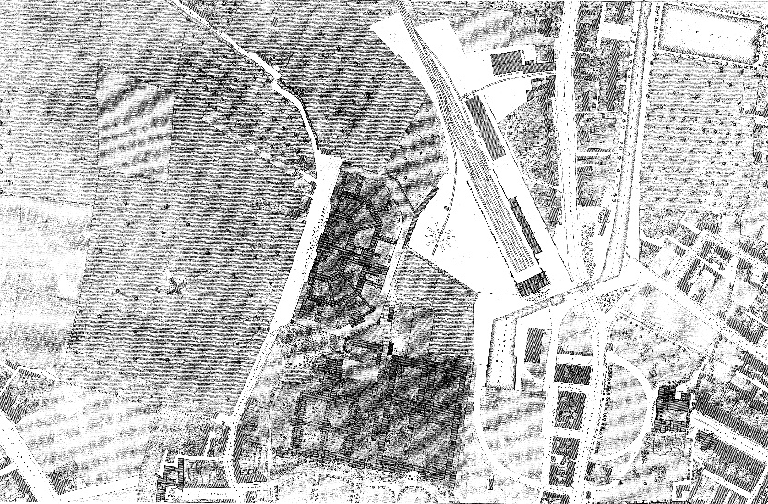

Location of the East Quad building overlaid on 1947 Ordnance Survey Map

### Archaeological Investigations

The test trenching undertaken across the proposed footprint of the East Quad indicated that extensive post-1800 structural remains were present. These seemed largely to relate to one of the wings of the Richmond Penitentiary and the early 19th century ancillary buildings associated with the Richmond Lunatic Asylum. A comprehensive programme of investigation and recording was then carried out to resolve the underlying archaeology in advance of GDA entering into a PPP to develop the new quad buildings here also.

The investigation confirmed that a significant section of the Richmond Penitentiary building and ancillary laundry building associated with the Richmond Lunatic Asylum survived within the footprint of the prosed East Quad development.



Findings for the East Quad excavations overlaid onto 1847 Ordnance Survey map