The Central Quadrangle Case-study

Background
The RDLA was constructed in 1854 to accommodate overcrowding in the Richmond Asylum. It originally comprised two substantial structures linked via a corridor. The most southern of the two housed the patients, while the second structure most likely accommodated supporting functions such as kitchens, laundry, workshops and storage. A number of ancillary buildings flanked the secondary structure.
Fire damage to the main southern wing and associated buildings to the north occurred in the 1950s and their subsequent demolition was undertaken in the early 1980s. The current upstanding remains of the Asylum consisting of the ‘Top House’ is a protected structure (RPS 3282), and it was retained as part of the redevelopment of the Grangegorman campus. The ‘Top House’ consists of a three-storey building representing approximately one fifth of the original RDLA complex.
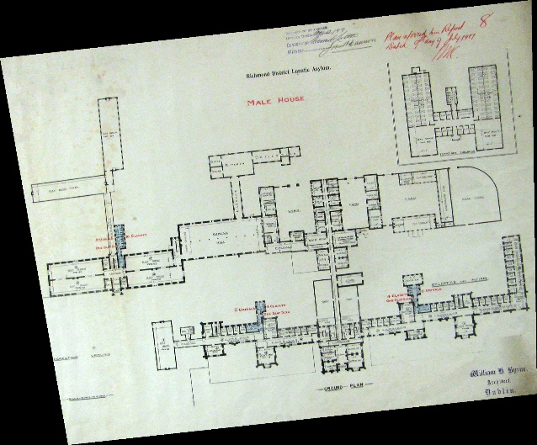
1899 plan of Richmond District Lunatic Asylum designed by W.G. Murray © Irish Architectural Archive
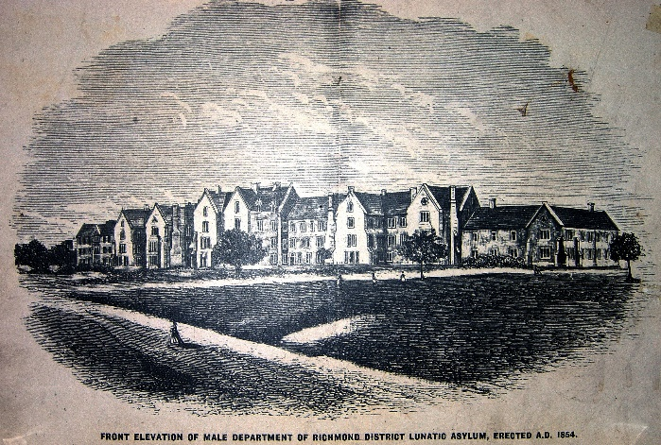
Sketch of front elevation of the Richmond District Lunatic Asylum, c.1878

Archaeological Investigations
The archaeological test trenching indicated that post-1800 structural remains associated with the Richmond District Lunatic Asylum (RDLA) were present across the footprint of the proposed Central Quad building. As the development of the central quad would require the removal of this material, it was recommended that a comprehensive programme of investigation and recording to resolve the archaeology on site be undertaken in advance of the GDA entering into a Public Private Partnership (PPP) to develop the new quad buildings.
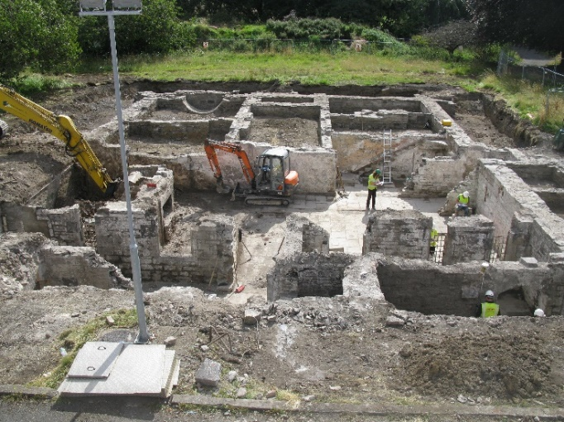

Overview of basement and ground floor of the Richmond District Lunatic Asylum

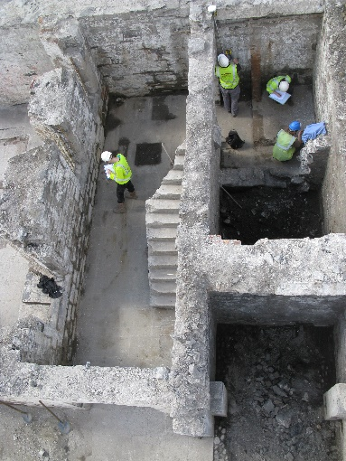
Building recording in progress

