The Bus Park: The North Union Workhouse
The bus park site was located at the eastern boundary of the campus, adjacent to the Dublin Bus depot at Broadstone. The House of Industry (which subsequently became the Dublin North Union Workhouse) was the earliest of the institutional buildings constructed at the site. Initially established in a disused malthouse on North Brunswick Street (in 1773), a new purpose-built building laid out in a quadrangle, was opened in 1791. In 1798 this building was extended with the addition of a second quadrangle on its north side to house the Bedford Asylum for Children. With the passing of the Poor Law in 1838 the entirety of the building became the Dublin North Union Workhouse.
We recommended here also that a comprehensive programme of investigation and recording to resolve the archaeology on site be undertaken in advance of the GDA developing the new bus park on behalf of Dublin Bus.
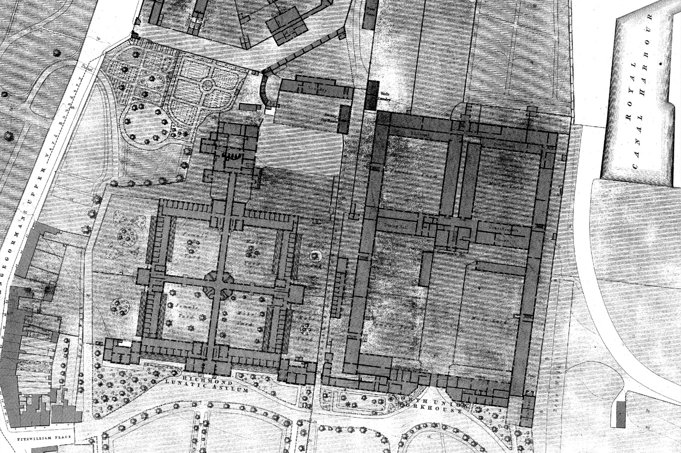
The most detailed early map is the Ordnance Survey 1:1056 series map of 1847, which shows the quadrangle plan form and internal layout of the North Union as well as including functional labelling for different sections of the complex

Archaeological Investigations
The results of the investigations undertaken indicated that sub-surface structural remains relating to the Dublin North Union Work House (formerly the House of Industry and Bedford Asylum) survived within the footprint of the proposed bus park. The section of the building within the site corresponds to the quadrangle labelled ‘Male Yard’ in the northeast of the complex on the 1847 Ordnance Survey map. The test trenching results indicated that most of the structure below ground level survived in the north and east wings.
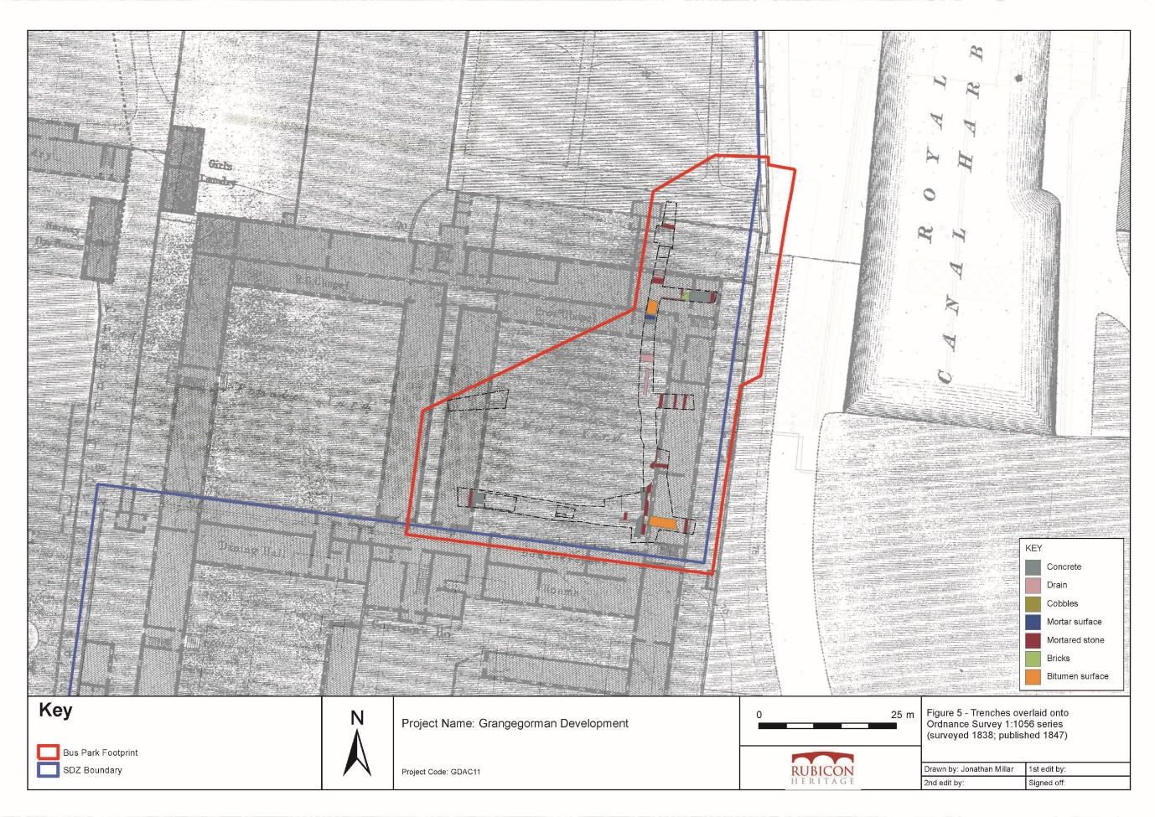
Results of test trenching at the proposed Bus Park site overlaid onto Ordnance Survey 25-inch series map (published 1847)

Mitigation
Our test trenching findings were subsequently taken into consideration when the foundation design for the proposed Bus Park was being planned. A minimum impact solution was implemented whereby the proposed bus park would be primarily supported on a piled foundation, facilitating the preservation in situ of the surviving sub-surface structural remains and enabling a solution for the proposed development in this area.

